Name : Shreyas Yadav

PRN : 202401040283

ROLL NO : 19

DIV : CS3

Q) Formulate 20 problem statements for a given dataset using Numpy and Pandas and Apply Numpy and pandas methods to find the solution for the formulated problem statements.

* **20 Problem Statements :  
  1**.Find the total number of reviews in the dataset.  
  **2.** Find how many preliminary decisions are missing.  
  **3.** Calculate the average review confidence.  
  **4.** Identify the maximum review evaluation score.  
  **5.** Count the number of each type of preliminary decision.  
  **6.** Find how many reviews have a confidence score greater than 4.  
  **7.** Find how many reviews are written in Spanish (es).  
  **8.** Calculate the percentage of missing review texts.  
  **9.** Calculate the average orientation value of the reviews.  
  **10.** Find the total number of unique reviewers (based on review__id).  
  **11.** Identify the top 5 longest reviews based on the number of characters.  
  **12.** Display the distribution (count) of each review confidence score.  
  **13.** Find the earliest review date from the timespan column.  
  **14.** Find the latest review date from the timespan column.  
  **15.** Find the number of reviews that have missing remarks.  
  **16.** Calculate the correlation between review confidence and review evaluation.  
  **17.** Find the total number of reviews for each preliminary decision category.  
  **18.** Find how many reviews are completely empty (no remarks and no review text).  
  **19.** Find the number of reviews where the evaluation score is greater than or equal to 2.  
  **20.** Identify the most common language used in the reviews.
* **CODE SNIPETS :**

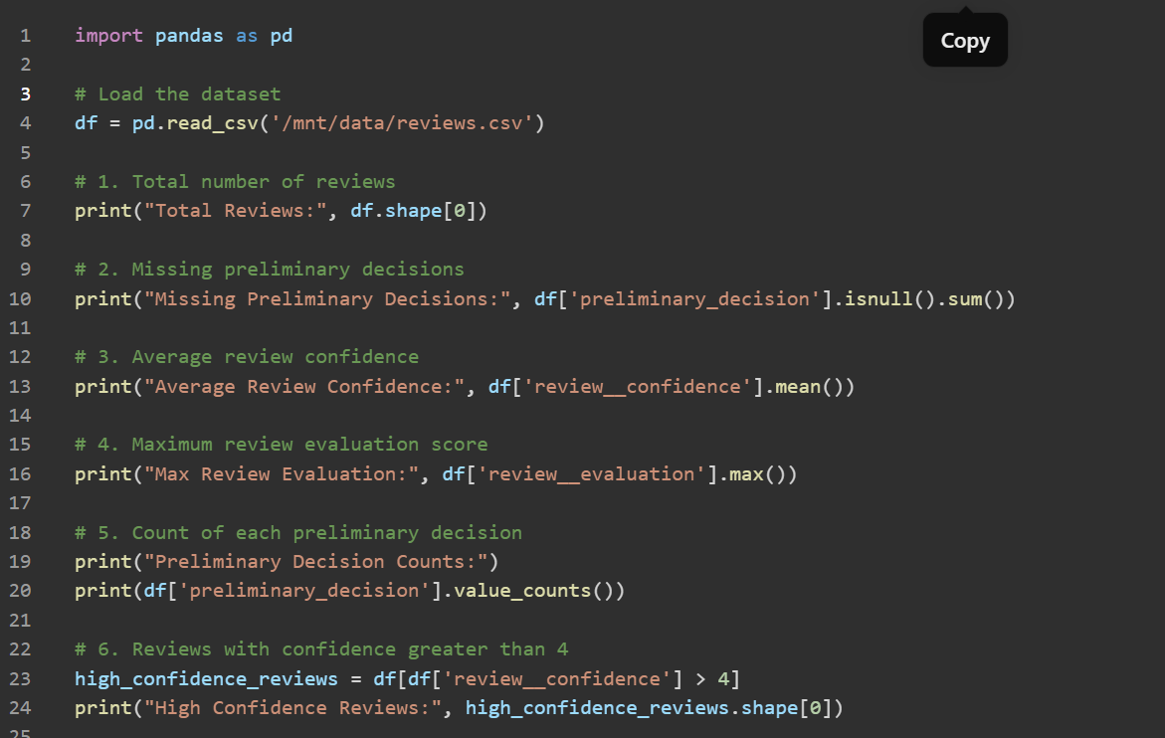

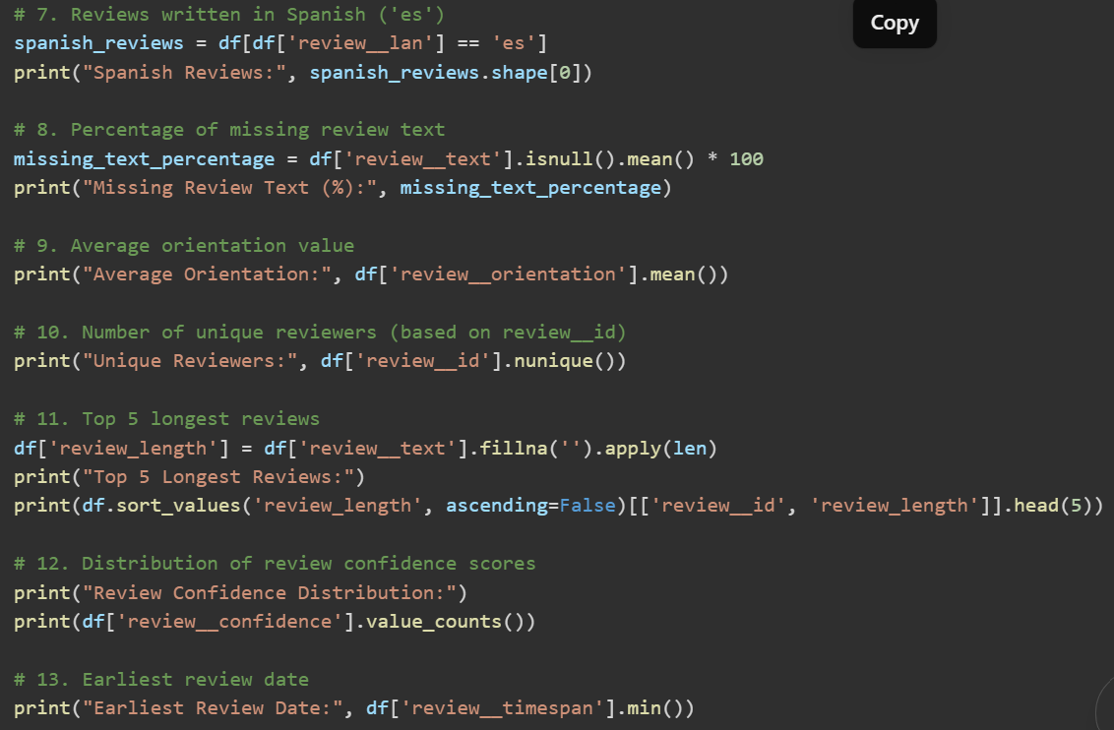

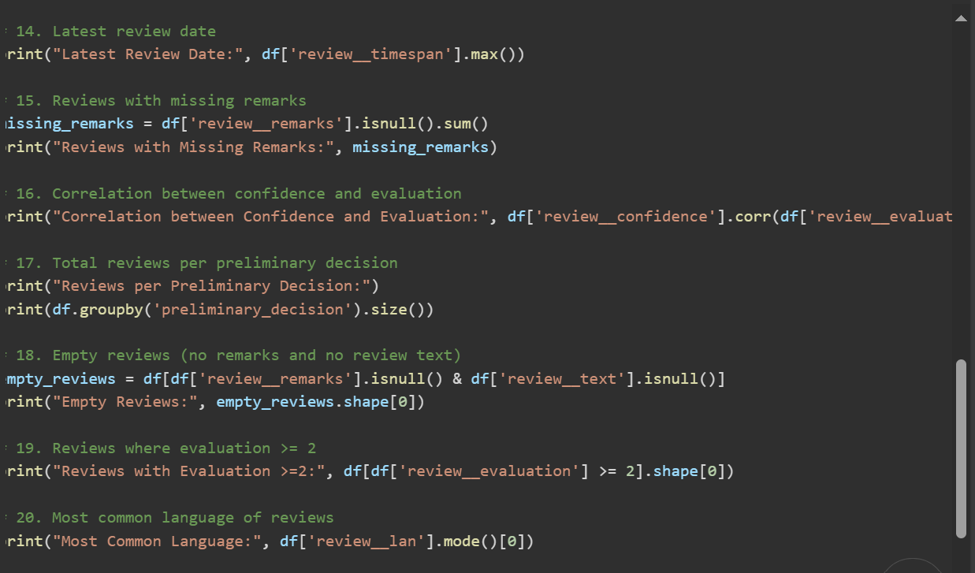

* **OUTPUT :**

